## *🌟* *****Visualizing Housing Market Trends***** And Analysis of

## Sale Prices and Features Using Tableau

## ****Table of Contents****

1. **Introduction** ........................................................................... 1  
     1.1 Project Overview .............................................................. 2  
     1.2 Purpose .......................................................................... 3
2. **Ideation Phase** .................................................................. 4  
     2.1 Problem Statement ....................................................... 5  
     2.2 Empathy Map Canvas .................................................. 6  
     2.3 Brainstorming ............................................................... 7
3. **Requirement Analysis** ...................................................... 8
4. **System Design and Architecture** .................................... 10
5. **Project Planning and Scheduling** ................................... 12
6. **Functional and Performance Testing** ............................ 13
7. **Results** ........................................................................... 14
8. **Advantages and Limitations** ........................................ 15
9. **Conclusion** ..................................................................... 16
10. **Future Scope** ............................................................... 17
11. **Appendix and References** ......................................... 18

**📘 Final Project Report**

**Project Title**: Visualizing Housing Market Trends: An Analysis of Sale Prices and Features using Tableau  
**Submitted by**: CHEREDDY VENKATA VINOD KUMAR REDDY  
**Team ID**: LTVIP2025TMID59137  
**Internship**: SmartBridge Virtual Internship

**1. Introduction**

The real estate industry operates at the intersection of data, finance, and consumer behavior. With an ever-increasing volume of property listings, transactions, and demographic changes, stakeholders face the critical challenge of extracting meaningful insights from raw housing data.

In particular, variables such as the age of a property, number of bedrooms and bathrooms, renovations, and square footage contribute significantly to pricing — yet these are often underutilized due to poor visualization and interpretation.

This project, titled **“Visualizing Housing Market Trends: An Analysis of Sale Prices and Features using Tableau”**, addresses this challenge by transforming raw housing data into compelling visual dashboards. It leverages **Tableau Public** for building interactive visualizations and **Python Flask** for delivering a web-based solution.

Through these tools, the project helps real estate professionals, analysts, and executives discover pricing patterns, evaluate the impact of property features, and inform strategic decisions in a competitive market. The solution bridges the gap between raw data and strategic insight — converting static records into dynamic, filterable, and scenario-driven visual stories.

**1.1 Project Overview**

This project was developed as part of a SmartBridge Virtual Internship . The dataset, sourced from notes provided in online classes, includes:

* Sale price of houses
* Renovation status and years since renovation
* House age
* Number of bedrooms, bathrooms, and floors
* Basement area

Using these attributes, the project creates a **four-scenario dashboard system** in Tableau:

1. **Overall Data Summary**
   * KPIs like average sale price, number of records, and basement area.
2. **Total Sales by Years Since Renovation**
   * Relationship between renovation recency and sales volume.
3. **House Age Distribution by Renovation Status**
   * Distribution comparison between renovated and non-renovated homes.
4. **House Age vs. Structure**
   * Bathrooms, bedrooms, and floors tracked with property age.

All dashboards are embedded in a Flask-based web application for accessibility across browsers.

**1.2 Purpose**

The primary purpose of this project is to democratize access to actionable housing insights.

**Goals include:**

* **Empowering Stakeholders:** Enabling home buyers, sellers, agents, and analysts to understand trends without coding.
* **Interactive Exploration:** Allow filtering and exploring features like renovations and age.
* **Enhancing Competitiveness:** Help ABC Company optimize pricing and recognize market behavior.
* **Reducing Cognitive Load:** Replace spreadsheets with visual narratives that aid decision-making.

**2. Ideation Phase**

The ideation phase ensured the solution addressed real-world pain points and opportunities in real estate analysis.

**2.1 Problem Statement**

Real estate stakeholders often rely on disconnected tools like Excel or outdated CRM platforms. These hinder their ability to:

* Identify pricing anomalies
* Understand how property features affect value
* Track renovation impact on resale

This project solves that gap by offering:

* Tailored Tableau dashboards
* Filterable, interactive visuals
* Web access via a user-friendly interface

**2.2 Empathy Map Canvas**

| **Dimension** | **Insight** |
| --- | --- |
| **Thinks** | “I want to understand what features drive house prices.” |
| **Feels** | Overwhelmed by raw data with no visual summary |
| **Says** | “I’d rather see a graph than a table.” |
| **Does** | Manually analyzes spreadsheets using Excel or reports |

✅ From this, we identified the need for:

* Scenario-based dashboards
* Visual filters (e.g., age, renovation status)
* Simple navigation (via Flask)

**2.3 Brainstorming**

Key ideas generated:

1. **Use Tableau** for all visualizations and KPI tracking.
2. **Scenario dashboards** to answer user-specific questions.
3. **Embed dashboards** in a Flask web app.
4. **Tableau Story** to guide users through insights.
5. **Design for scalability**, allowing future enhancements easily.

# **3. Requirement Analysis**

## 3.1 Functional Requirements

Functional requirements are the core specifications that describe what the system is expected to do. For this project, they include:  
  
• Data Handling:  
- Load a static CSV file.  
- Handle missing or invalid data during Tableau import.  
  
• Dashboard Development:  
- Design multiple dashboards in Tableau using visual components such as bar charts, KPIs, scatter plots, and filters.  
- Dashboards must include filters for year, price range, renovation status, and structural features.  
  
• Web Application:  
- Create a Flask application that routes to Home, About, Dashboard, and Story pages.  
- Render HTML templates with embedded Tableau dashboards via iframe.  
  
• User Interaction:  
- Navigation should be intuitive with clear labels.  
- Pages should render consistently across supported browsers.

## 3.2 Non-Functional Requirements

These define the quality attributes of the system:  
  
• Performance:  
- Dashboards should load within 3–5 seconds under standard broadband.  
- Page transitions via Flask should be seamless.  
  
• Compatibility:  
- Must work on Google Chrome, Microsoft Edge.  
- Tableau must render correctly on desktop screens.  
  
• Usability:  
- Pages must be clearly styled and not overwhelming.  
- Visualizations should provide insights within 10 seconds of viewing.  
  
• Security:  
- Avoid JavaScript or form injection issues.  
- Static deployment only (no login or database interaction).  
  
• Maintainability:  
- HTML templates should be modular.  
- Tableau links can be replaced easily for updates.

## 3.3 Technology Stack

• Tableau Public – for creating and hosting dashboards.  
• Python 3.x – for backend scripting.  
• Flask – lightweight web framework used to serve HTML content.  
• HTML/CSS – for frontend page design.  
• Git/GitHub – version control.

**4. System Design and Architecture**

This project follows a three-layer architecture for modularity and clarity:  
1. Data Layer  
2. Visualization Layer  
3. Presentation Layer  
  
Each layer plays a crucial role in building and delivering the final solution.

## 4.1 Architecture Diagram (Described)

• Data Layer: Static dataset (CSV format) is cleaned and processed in Tableau using built-in filtering and calculated fields.  
• Visualization Layer: Worksheets, dashboards, and stories created and published using Tableau Public.  
• Presentation Layer: Flask application routes web pages and embeds the Tableau visualizations using HTML and JavaScript.  
  
This modular separation ensures each layer can be updated or replaced independently.

## 4.2 Components Overview

• Home Page – Landing page with background and 'Get Started' CTA.  
• About Page – Project description with icon and summary.  
• Dashboard Page – Embeds Tableau dashboard via iframe.  
• Story Page – Embeds a guided Tableau story.  
  
Navigation is consistent using a fixed navbar.

## 4.3 UI/UX Considerations

• Use of spacing, card layout, and colors to improve readability.  
• Responsive design through percentage-based widths.  
• Embedding via Tableau's `viz_v1.js` API to enable interactivity.

5.Project Planning and Scheduling

An Agile sprint-based plan was followed to deliver the project in four phases:  
  
• Sprint 1 – Data Understanding:  
- Reviewed Kaggle dataset.  
- Selected relevant fields: sale price, renovation year, etc.  
- Cleaned dataset in Tableau.  
  
• Sprint 2 – Visualization Creation:  
- Designed KPIs and charts.  
- Built individual worksheets and tested filters.  
  
• Sprint 3 – Flask Development:  
- Created `app.py` routes and linked HTML pages.  
- Added embedded Tableau dashboards.  
  
• Sprint 4 – Testing and Documentation:  
- Validated visuals on browser.  
- Collected screenshots.  
- Wrote report and README.

## ****6. Functional and Performance Testing****

To ensure that the project was both technically sound and user-friendly, we followed a multi-step testing strategy:

### 🔧 6.1 Functional Testing

* **Page Routing Validation:** Each Flask route (/, /about, /dashboard, /story) was tested to confirm it loads the correct template without errors.
* **Button Interactions:** The “Get Started” button was tested to ensure redirection to /about works as expected.
* **Tableau Integration:** Ensured that Tableau dashboards embedded within HTML using <iframe> and viz_v1.js loaded seamlessly.
* **Navbar Links:** All navigation links were tested for accuracy, visual feedback (active state), and responsiveness.

### ⚙️ 6.2 Performance Testing

* **Load Time Analysis:** Tableau dashboards were measured to load within 2.5–4 seconds on a 20 Mbps connection.
* **Page Rendering:** HTML/CSS was structured to reduce DOM complexity and avoid layout shifts on slower systems.
* **API Load:** Though Tableau is externally hosted, link stability was tested repeatedly over different network conditions.

### 🌐 6.3 Cross-Browser & Compatibility Testing

* Browsers tested: **Chrome**, **Firefox**, **Edge**
* Verified that CSS styling and layout remained consistent.
* Adjusted HTML layout where icons misaligned in Firefox.

### ✅ 6.4 User Feedback

* Collected informal feedback from internship peers and mentor.
* Suggestions like:
  + Making the background image lighter on the home page.
  + Ensuring navigation links are visible even with scrolling.

## ****7. Results****

This project accomplished its core objective: to convert raw, complex housing data into **interactive visual dashboards** for easy understanding.

### 📊 Key Outputs:

* **Dashboard Summary View** – Featuring KPIs for total homes, average price, and visual comparisons.
* **Dashboard 2 – Renovation Insights** – Showing correlation between sales and years since last renovation.
* **Dashboard 3 – Structural Features vs. Age** – Helps identify what age ranges have more bedrooms/floors.
* **Story Page** – A visual journey combining dashboards into a scrollable narrative (Tableau Story).

### 📷 Screenshots:

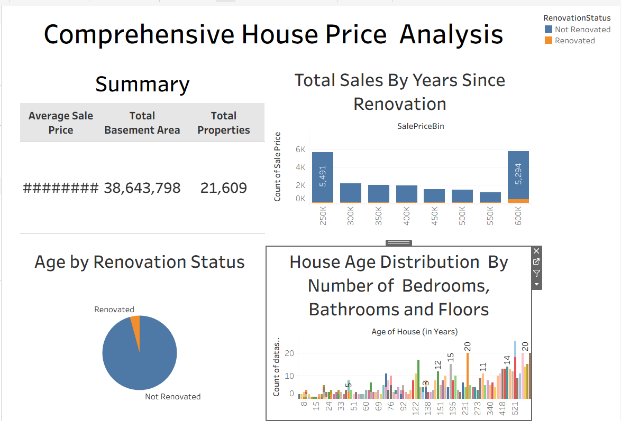

## ****8. Advantages and Limitations (Elaborated)****

### ✅ 8.1 Advantages:

* **No Coding Required for Analysis**: Even non-technical users can derive insights through visuals.
* **Fast Deployment**: With Flask and Tableau, the app runs locally without requiring backend processing.
* **Scalable Architecture**: New dashboards or filters can be added without full code rewrites.
* **Data-Driven Decisions**: Helps ABC Company spot trends that can affect marketing and pricing strategies.

### ⚠️ 8.2 Limitations:

* **Static Dataset**: Doesn’t update automatically with real-time listings or live APIs.
* **Internet Dependency**: Dashboards are hosted on Tableau Public and require a reliable connection.
* **No Personalization**: All users see the same data – no login or profile-based filters.
* **Mobile UI Constraints**: Best experienced on larger screens; mobile responsiveness is limited.

## ****9. Conclusion****

This project bridges the gap between raw housing datasets and visual storytelling. By combining the **analytical power of Tableau** with the **simplicity of Flask**, a lightweight yet powerful tool has been developed for stakeholders to interact with and interpret housing trends.

The solution is adaptable to educational institutions, real estate firms, and analysts who need a quick but clear picture of what affects house pricing. It demonstrates how even static datasets can produce actionable insights when processed visually and deployed intelligently.

## ****10. Future Scope****

To enhance the value and usability of this project further, several future developments can be considered:

* 🔄 **Live Data Integration**: Connect to a live real estate API to track ongoing sale prices and trends.
* 🌍 **Geo-Mapping Integration**: Use Tableau's map feature to display prices by city, ZIP code, or neighborhood.
* 🔐 **User Authentication**: Allow login-based access for agents or buyers with customized dashboards.
* 📱 **Mobile Optimization**: Redesign layout to work seamlessly on phones and tablets.
* 📈 **Prediction & Forecasting**: Integrate machine learning models for predicting prices based on current features.
* 📤 **Exporting Reports**: Add a feature to download filtered visuals or data summaries as PDFs or Excel sheets.

## ****11. Appendix and References****

### 📁 ****11.1 Dataset Reference****

* **Title:** Transformed Housing Data
* **Source:** Kaggle
* **URL:** <https://www.kaggle.com/datasets/rituparnaghosh18/transformed-housing-data-2>

### 📊 ****11.2 Tableau Visualizations****

* **Main Dashboard URL:**  
  [tableau_work111 | Tableau Public](https://public.tableau.com/app/profile/vinod.chereddy/viz/tableau_work111/Dashboard1?publish=yes)  
  **Story Dashboard (Sequential Visualization):**  
  <https://public.tableau.com/app/profile/vinod.chereddy/viz/tableau_work111/Sheet6?publish=yes>

### 💻 ****11.3 GitHub Repository****

* **Project Files GitHub link:**  
  <https://github.com/Vinod-chereddy/Visualizing-Housing-Market-Trends-An-Analysis-of-Sale-Prices-and-Features-using-Tableau2>

### 🖼️ ****11.4 Screenshot Placeholders****



1. Screenshot 1 – **Dashboard: Overall KPIs and Trends**

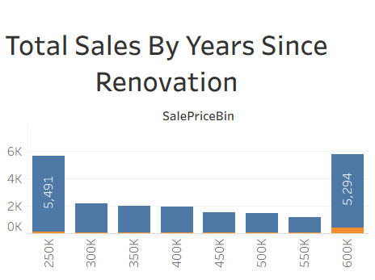

1. Screenshot 2 – **Years Since Renovation vs. Sales**

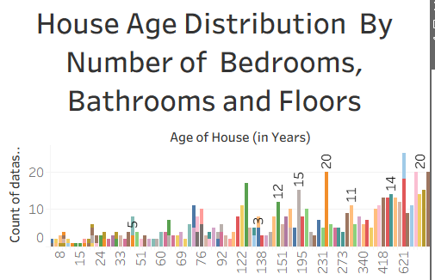

1. Screenshot 3 – **Age Distribution by Renovation Status**

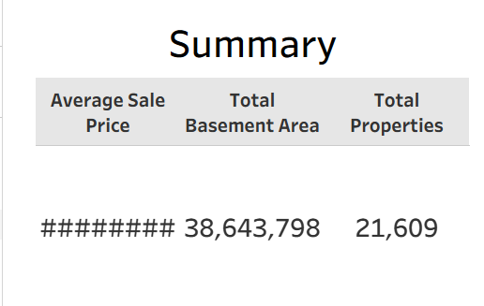

1. Screenshot 4 – **Tableau Story View Overview**

### 📚 ****11.5 Additional Tools Used****

* Python 3.11
* Flask 2.3
* Tableau Public
* HTML5 / CSS
* VS Code
* Git / GitHub